Lab Activity: Foundations of Linux Firewalls (iptables & nftables)
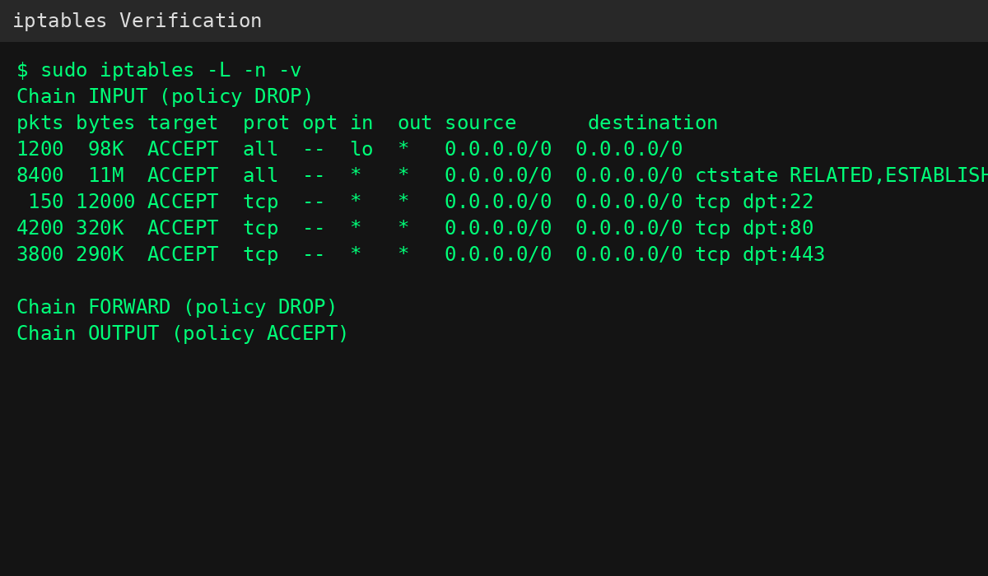
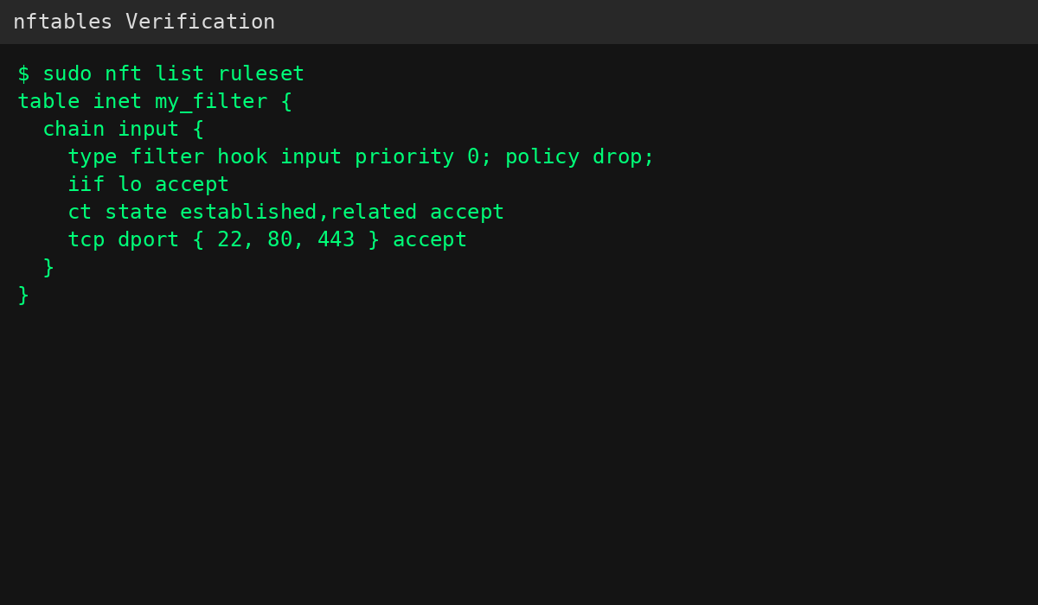
. Stateful vs. Stateless
The ESTABLISHED,RELATED rule is necessary because it allows incoming packets that belong to connections already initiated by the server. When the server sends a request to an external service, such as during sudo apt update, the response packets must be allowed back into the system.
Without the ESTABLISHED,RELATED rule, the firewall would drop the reply packets even though the server initiated the connection. As a result, commands such as sudo apt update would fail because the package repository responses would never reach the server.

2. Order of Operations
No, the SSH rule would not work if a DROP ALL rule was placed at the very top of the INPUT chain.
iptables follows a "First Match Wins" principle. Once a packet matches a rule, the corresponding action is immediately applied and no other rules are checked. If a DROP ALL rule appears first, every incoming packet would be dropped before reaching the SSH rule, making remote administration impossible.

3. nftables Advantage
One major advantage of nftables is its ability to combine multiple ports into a single rule.
iptables:
sudo iptables -A INPUT -p tcp --dport 22 -j ACCEPT
sudo iptables -A INPUT -p tcp --dport 80 -j ACCEPT
sudo iptables -A INPUT -p tcp --dport 443 -j ACCEPT
nftables:
sudo nft add rule inet my_filter input tcp dport { 22, 80, 443 } accept
This syntax is easier to read, reduces the number of rules, and simplifies management in large-scale networks.

